**Exercise 9:**

**ListOfPlayers.js:**

// src/components/ListOfPlayers.js

import React from 'react';

const ListOfPlayers = () => {

const players = [

{ name: "Virat", score: 95 },

{ name: "Rohit", score: 88 },

{ name: "Dhoni", score: 70 },

{ name: "Jadeja", score: 67 },

{ name: "Pant", score: 92 },

{ name: "Bumrah", score: 85 },

{ name: "Shami", score: 78 },

{ name: "Gill", score: 65 },

{ name: "Ishan", score: 60 },

{ name: "Ashwin", score: 72 },

{ name: "Surya", score: 99 },

];

// Filter players with score < 70 using arrow function

const below70 = players.filter(player => player.score < 70);

return (

<div>

<h2>All Players</h2>

<ul>

{players.map((player, index) => (

<li key={index}>{player.name} - {player.score}</li>

))}

</ul>

<h2>Players with Score Below 70</h2>

<ul>

{below70.map((player, index) => (

<li key={index}>{player.name} - {player.score}</li>

))}

</ul>

</div>

);

};

export default ListOfPlayers;

**IndianPlayers.js:**

// src/components/IndianPlayers.js

import React from 'react';

const IndianPlayers = () => {

const players = [

"Virat", "Rohit", "Dhoni", "Jadeja", "Pant",

"Bumrah", "Shami", "Gill", "Ishan", "Ashwin", "Surya"

];

// Destructure players into even and odd index teams

const oddTeam = players.filter((_, index) => index % 2 !== 0);

const evenTeam = players.filter((_, index) => index % 2 === 0);

// Merge arrays

const T20Players = ["Virat", "Rohit", "Pant"];

const RanjiPlayers = ["Pujara", "Rahane", "Saha"];

const mergedPlayers = [...T20Players, ...RanjiPlayers];

return (

<div>

<h2>Odd Team Players</h2>

<ul>

{oddTeam.map((player, index) => (

<li key={index}>{player}</li>

))}

</ul>

<h2>Even Team Players</h2>

<ul>

{evenTeam.map((player, index) => (

<li key={index}>{player}</li>

))}

</ul>

<h2>Merged Team: T20 + Ranji Trophy Players</h2>

<ul>

{mergedPlayers.map((player, index) => (

<li key={index}>{player}</li>

))}

</ul>

</div>

);

};

export default IndianPlayers;

**App.js:**

// src/App.js

import React from 'react';

import ListOfPlayers from './components/ListOfPlayers';

import IndianPlayers from './components/IndianPlayers';

function App() {

const flag = true; // Change to false to see IndianPlayers

return (

<div className="App">

<h1>🏏 Cricket App</h1>

{flag ? <ListOfPlayers /> : <IndianPlayers />}

</div>

);

}

export default App;

**Output:**

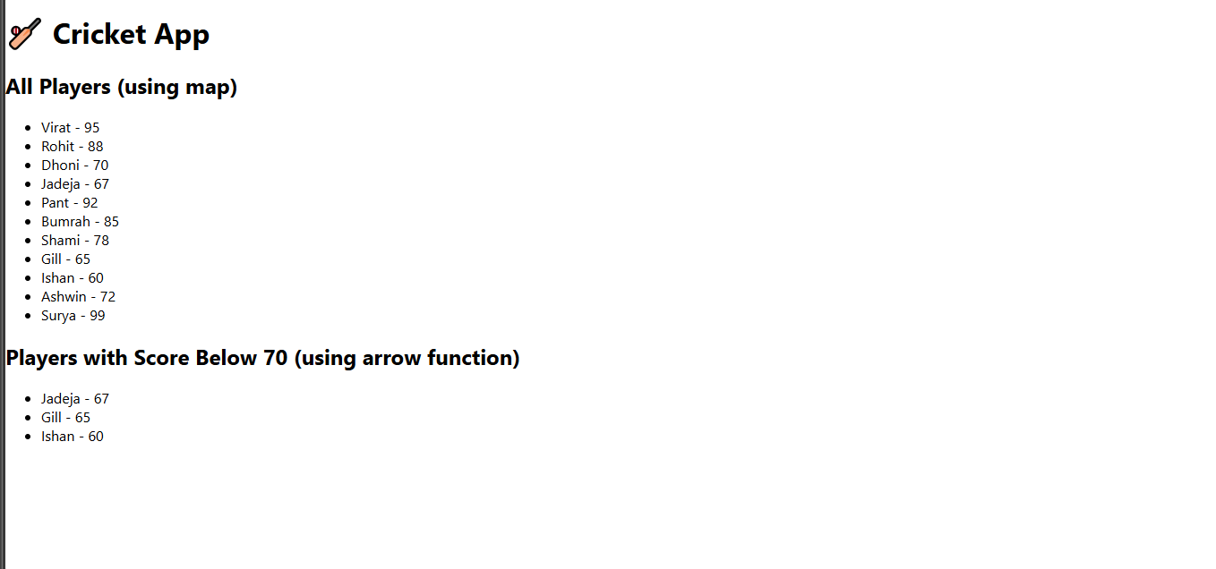

**App.js:**

import React from 'react';

import ListOfPlayers from './components/ListOfPlayers';

import IndianPlayers from './components/IndianPlayers';

function App() {

const flag = false; // Change to false to see IndianPlayers instead

return (

<div className="App">

<h1>🏏 Cricket App</h1>

{flag ? <ListOfPlayers /> : <IndianPlayers />}

</div>

);

}

export default App;

**Output:**

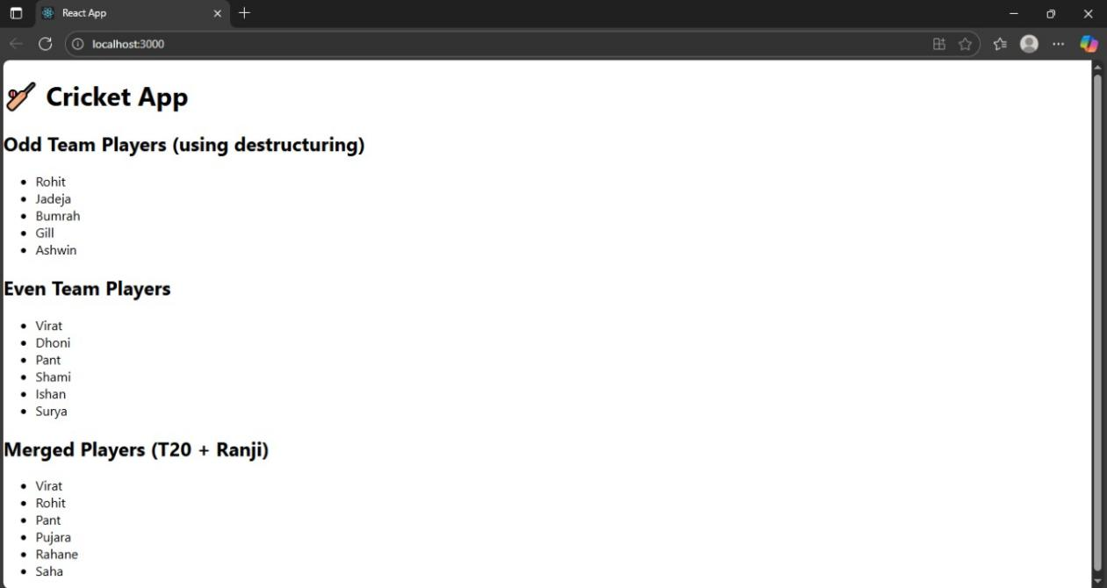

**Exercise 10:**

**App.js:**

import './App.css';

function App() {

const heading = <h1>Office Space Rental</h1>;

const imageUrl = "https://content.instantoffices.com/sc/Prod/images/centres/1600width/119356/119356-810995.jpg";

const image = (

<div style={{ textAlign: "center", margin: "20px 0" }}>

<img

src={imageUrl}

alt="Office Space"

style={{

width: "300px",

height: "200px",

objectFit: "cover",

borderRadius: "10px",

boxShadow: "0 4px 8px rgba(0,0,0,0.2)"

}}

/>

</div>

);

const offices = [

{ name: "Orchid Tech Park", rent: 55000, address: "Whitefield" },

{ name: "Prestige Shantiniketan", rent: 75000, address: "ITPL" },

];

return (

<div style={{ padding: "20px", fontFamily: "Arial" }}>

{heading}

{image}

{offices.map((office, index) => (

<div

key={index}

style={{

border: "1px solid black",

margin: "10px auto",

padding: "10px",

maxWidth: "500px",

textAlign: "left",

borderRadius: "8px"

}}

>

<h2>{office.name}</h2>

<p>Address: {office.address}</p>

<p style={{ color: office.rent < 60000 ? 'red' : 'green' }}>

Rent: ₹{office.rent}

</p>

</div>

))}

</div>

);

}

export default App;

**Output:**

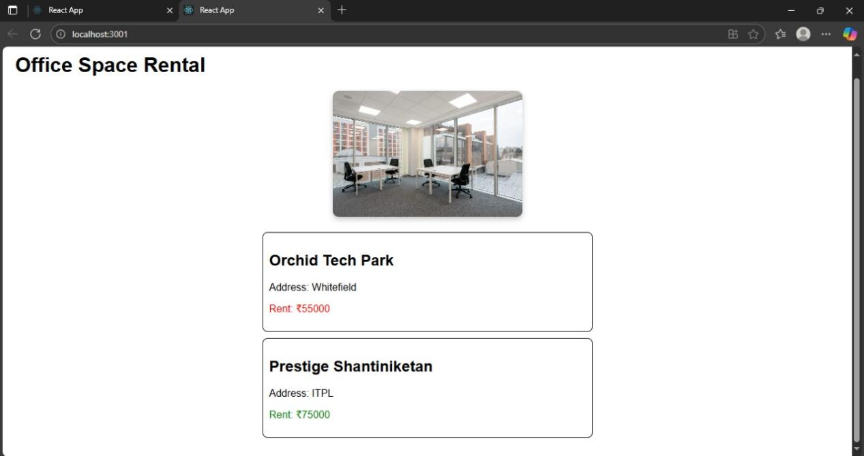

**Exercise 11:**

**App.js:**

import React from 'react';

import './App.css';

import CurrencyConvertor from './CurrencyConvertor';

class App extends React.Component {

constructor() {

super();

this.state = {

count: 0

};

}

increment = () => {

this.setState({ count: this.state.count + 1 });

};

sayHello = () => {

alert("Hello! This is a static message.");

};

handleIncrementClick = () => {

this.increment();

this.sayHello();

};

decrement = () => {

this.setState({ count: this.state.count - 1 });

};

sayWelcome = (message) => {

alert(Welcome! ${message});

};

handleSyntheticEvent = (event) => {

event.preventDefault();

alert("I was clicked");

};

render() {

return (

<div className="App">

<h2>Counter: {this.state.count}</h2>

<button onClick={this.handleIncrementClick}>Increment</button>

<button onClick={this.decrement}>Decrement</button>

<br /><br />

<button onClick={() => this.sayWelcome("Welcome to React!")}>Say Welcome</button>

<br /><br />

<button onClick={this.handleSyntheticEvent}>OnPress</button>

<hr />

<CurrencyConvertor />

</div>

);

}

}

export default App;

**CurrencyConvertor.js:**

import React, { Component } from 'react';

class CurrencyConvertor extends Component {

constructor() {

super();

this.state = {

rupees: '',

euro: ''

};

}

handleChange = (event) => {

this.setState({ rupees: event.target.value });

};

handleSubmit = (event) => {

event.preventDefault();

const euroValue = (parseFloat(this.state.rupees) / 90).toFixed(2); // Assuming 1 Euro = 90 INR

this.setState({ euro: euroValue });

};

render() {

return (

<div>

<h3>Currency Converter (INR to EURO)</h3>

<form onSubmit={this.handleSubmit}>

<input

type="number"

value={this.state.rupees}

onChange={this.handleChange}

placeholder="Enter amount in INR"

/>

<button type="submit">Convert</button>

</form>

<p>Converted Value: €{this.state.euro}</p>

</div>

);

}

}

export default CurrencyConvertor;

**Output:**

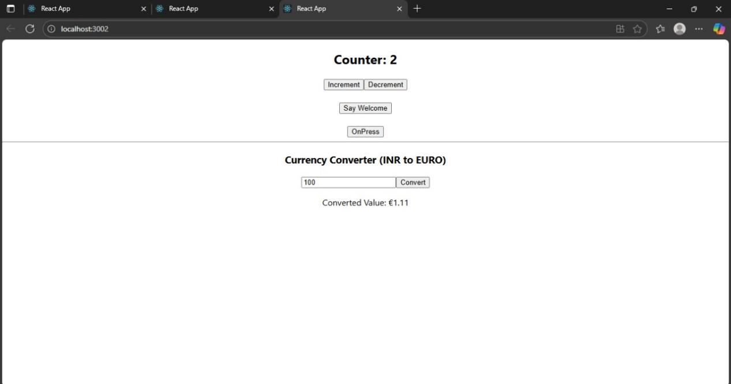

**Exercise 12:**

**GuestPage.js:**

import React from 'react';

import FlightDetails from './FlightDetails';

function GuestPage() {

return (

<div>

<h2>Welcome Guest!</h2>

<p>Please log in to book tickets.</p>

<FlightDetails />

</div>

);

}

export default GuestPage;

**UserPage.js:**

import React from 'react';

import FlightDetails from './FlightDetails';

function UserPage() {

return (

<div>

<h2>Welcome User!</h2>

<p>You can now book your tickets.</p>

<FlightDetails />

<button>Book Ticket</button>

</div>

);

}

export default UserPage;

**FlightDetails.js:**

import React from 'react';

function FlightDetails() {

return (

<div>

<h3>Flight Details</h3>

<ul>

<li>Flight: AI-202 | From: Delhi | To: Mumbai | Time: 10:00 AM</li>

<li>Flight: AI-203 | From: Chennai | To: Bangalore | Time: 12:00 PM</li>

</ul>

</div>

);

}

export default FlightDetails;

**LoginButton.js:**

function LoginButton({ onClick }) {

return <button onClick={onClick}>Login</button>;

}

export default LoginButton;

**LogoutButton.js:**

function LogoutButton({ onClick }) {

return <button onClick={onClick}>Logout</button>;

}

export default LogoutButton;

**App.js:**

import React, { useState } from 'react';

import GuestPage from './components/GuestPage';

import UserPage from './components/UserPage';

import LoginButton from './components/LoginButton';

import LogoutButton from './components/LogoutButton';

function App() {

const [isLoggedIn, setIsLoggedIn] = useState(false);

const handleLoginClick = () => setIsLoggedIn(true);

const handleLogoutClick = () => setIsLoggedIn(false);

let page;

let button;

if (isLoggedIn) {

page = <UserPage />;

button = <LogoutButton onClick={handleLogoutClick} />;

} else {

page = <GuestPage />;

button = <LoginButton onClick={handleLoginClick} />;

}

return (

<div className="App">

<h1>✈ Ticket Booking App</h1>

{button}

{page}

</div>

);

}

export default App;

**Output:**

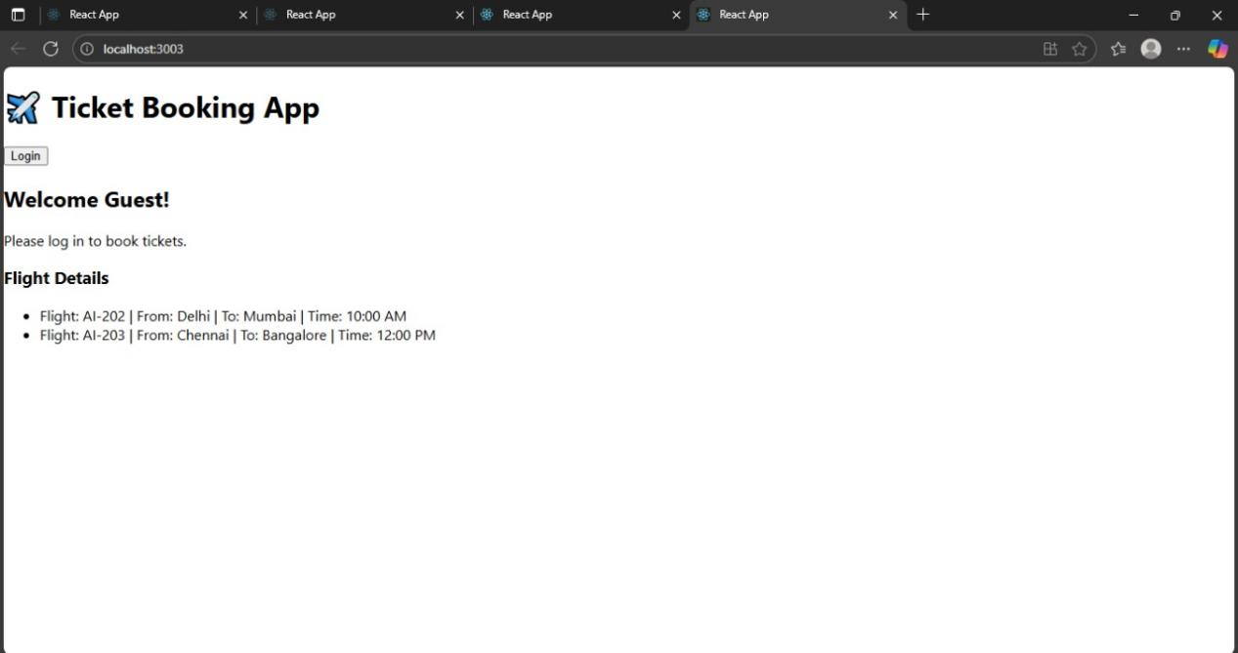

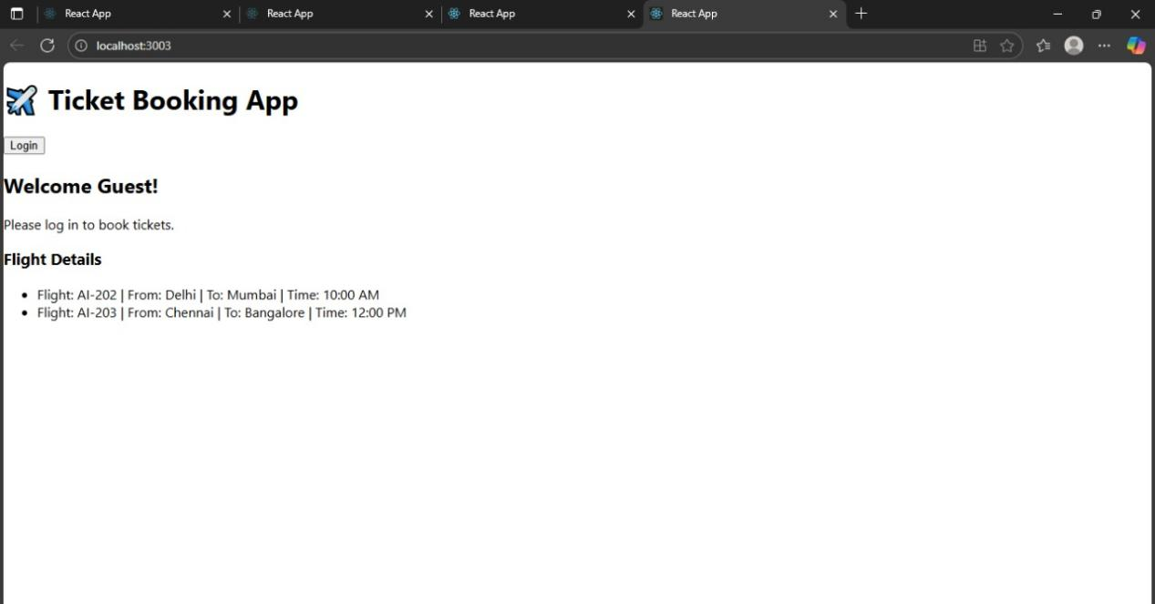

**Exercise 13:**

**Data .js:**

export const books = [

{ id: 101, bname: 'Master React', price: 670 },

{ id: 102, bname: 'Deep Dive into Angular 11', price: 800 },

{ id: 103, bname: 'Mongo Essentials', price: 450 }

];

export const blogs = [

{

id: 1,

title: 'React Learning',

author: 'Stephen Biz',

content: 'Welcome to learning React!'

},

{

id: 2,

title: 'Installation',

author: 'Schwezdenier',

content: 'You can install React from npm.'

}

];

export const courses = [

{ id: 1, cname: 'Angular', date: '4/5/2021' },

{ id: 2, cname: 'React', date: '6/3/20201' }

];

**App.js:**

import React from 'react';

import './App.css';

import { books, blogs, courses } from './data';

function App() {

const bookdet = (

<ul>

{books.map((book) => (

<div key={book.id}>

<h3>{book.bname}</h3>

<h4>{book.price}</h4>

</div>

))}

</ul>

);

const content = (

<ul>

{blogs.map((blog) => (

<div key={blog.id}>

<h3>{blog.title}</h3>

<h5><strong>{blog.author}</strong></h5>

<p>{blog.content}</p>

</div>

))}

</ul>

);

const coursedet = (

<ul>

{courses.map((course) => (

<div key={course.id}>

<h3>{course.cname}</h3>

<h4>{course.date}</h4>

</div>

))}

</ul>

);

return (

<div className="container">

<div className="mystyle1">

<h1>Course Details</h1>

{coursedet}

</div>

<div className="st2">

<h1>Book Details</h1>

{bookdet}

</div>

<div className="v1">

<h1>Blog Details</h1>

{content}

</div>

</div>

);

}

export default App;

**App.css:**

.container {

display: flex;

justify-content: space-around;

padding: 40px;

}

.mystyle1, .st2, .v1 {

padding: 10px;

width: 30%;

font-family: Arial, sans-serif;

}

.st2, .v1 {

border-left: 5px solid green;

}

**Output:**

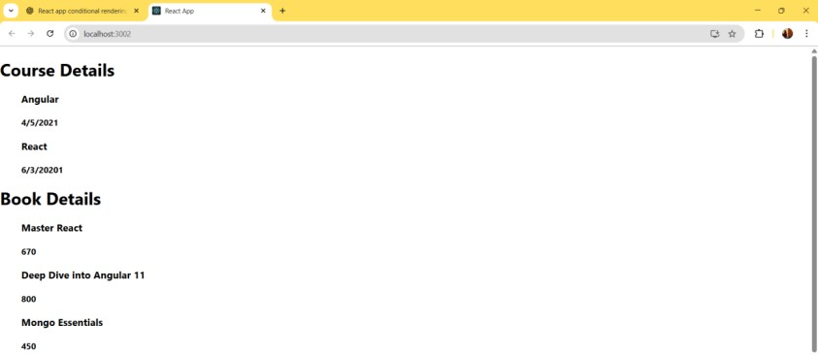

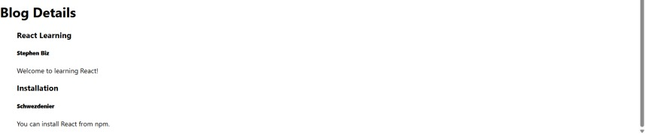

**Additional hands_on:**

**Exercise 14:**

**ThemeContext.js:**

import { createContext } from 'react';

// Step: create a context with default value 'light'

const ThemeContext = createContext('light');

export default ThemeContext;

**App.js:**

import React, { useState } from 'react';

import EmployeeList from './EmployeeList';

import ThemeContext from './ThemeContext';

function App() {

const [theme, setTheme] = useState('light');

return (

<ThemeContext.Provider value={theme}>

<div style={{ padding: '20px' }}>

<h1>Employee Management</h1>

<button onClick={() => setTheme(theme === 'light' ? 'dark' : 'light')}>

Toggle Theme

</button>

<EmployeeList />

</div>

</ThemeContext.Provider>

);

}

export default App;

**EmployeeList.js:**

import React from 'react';

import EmployeeCard from './EmployeeCard';

function EmployeeList() {

const employees = [

{ id: 1, name: 'Alice', designation: 'Developer' },

{ id: 2, name: 'Bob', designation: 'Designer' }

];

return (

<div>

{employees.map(emp => (

<EmployeeCard key={emp.id} employee={emp} />

))}

</div>

);

}

export default EmployeeList;

**EmployeeCard.js:**

import React, { useContext } from 'react';

import ThemeContext from './ThemeContext';

function EmployeeCard({ employee }) {

const theme = useContext(ThemeContext); // use context to get theme

const buttonClass =

theme === 'dark' ? 'btn btn-dark' : 'btn btn-light';

const cardStyle = {

border: '1px solid #ccc',

margin: '10px',

padding: '10px',

borderRadius: '8px'

};

return (

<div style={cardStyle}>

<h4>{employee.name}</h4>

<p>{employee.designation}</p>

<button className={buttonClass}>View Profile</button>

</div>

);

}

export default EmployeeCard;

**index.css:**

.btn {

padding: 10px 20px;

border: none;

margin-top: 10px;

cursor: pointer;

font-weight: bold;

border-radius: 4px;

}

.btn-light {

background-color: #f0f0f0;

color: black;

}

.btn-dark {

background-color: black;

color: white;

}

**index.js:**

import React from 'react';

import ReactDOM from 'react-dom/client';

import './index.css';

import App from './App';

const root = ReactDOM.createRoot(document.getElementById('root'));

root.render(<App />);

**Output:**

